Import Data using Transform Maps (Spreadsheet)
Milestone 1 : Creation Of Spreadsheet And Table
Creation Of Spreadsheet
Description
The spreadsheet data will be uploaded into a ServiceNow Import Set Table, where it will be validated and transformed before being inserted or updated in the target banking table using a Transform Map.
Prepare the sheets
Open New Google Spreadsheet
Create New Google Spreadsheet with sample data as shown below

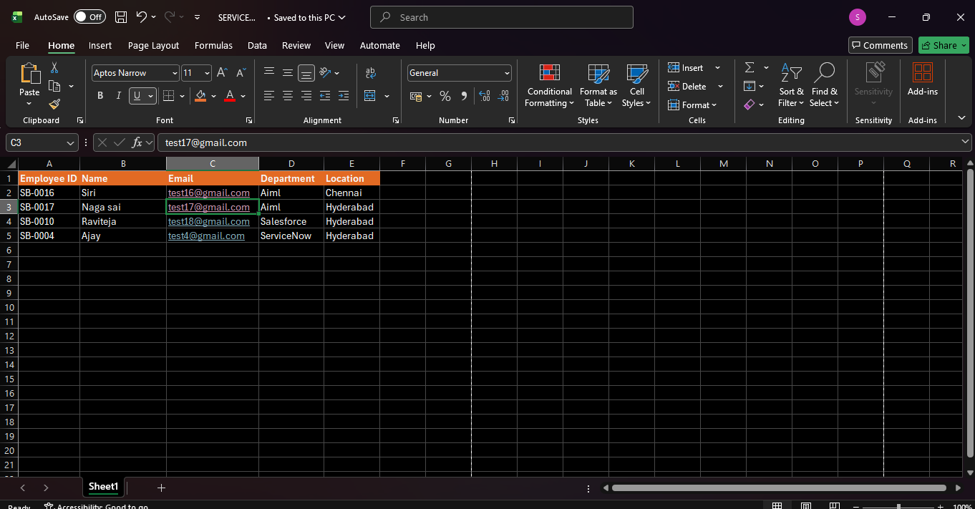

Creation of Tables
Description
The Import Set Table acts as a temporary staging table for the data uploaded from the spreadsheet. The imported spreadsheet records are stored here before transformation.
Create new Custom table
Navigation:
- Tables > Create New
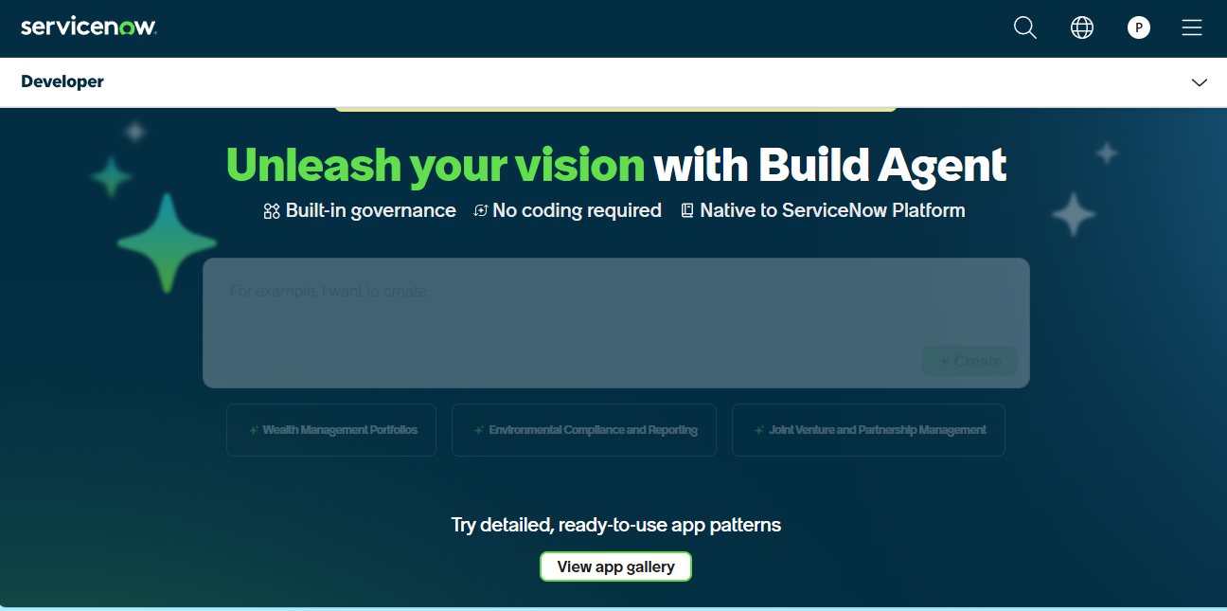
- Label: Employee Test Name: u_employee_test
- After creating and saving the Employee Test table
- scroll down and go to related links
- click on show form

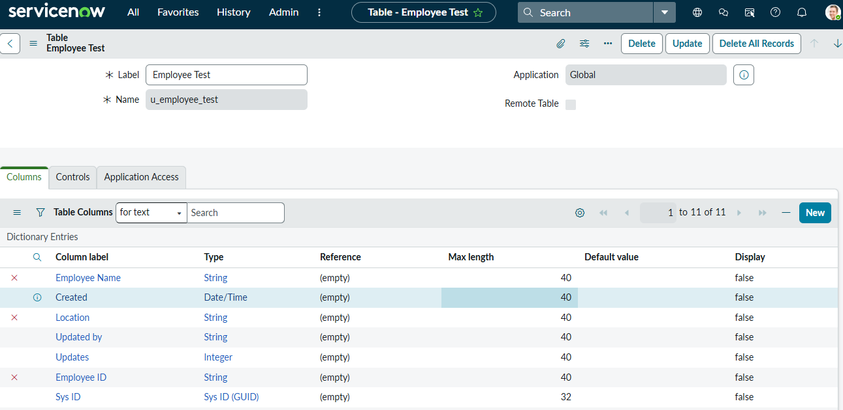
- On the form, locate the Form Context Menu / Additional Actions option on the left side of the form header.\
- Click the Form Context Menu / Additional Actions icon.
- Click configure , select Form Layout.
- The Form Layout page will open, where you can configure the fields displayed on the form
- After opening Form Layout, click New to create a new field.
- Enter the field details:
- Column Label: Employee ID
- Type: String
- Click Add to create the field.
- Repeat the same steps to create the following fields:
- Employee Name – Type: String
- Email – Type: String
- Department – Type: String
- Location – Type: String
- After creating all the required fields, click Save.
- Verify that the newly created fields are displayed on the Employee Test form
- Click on Submit or Save

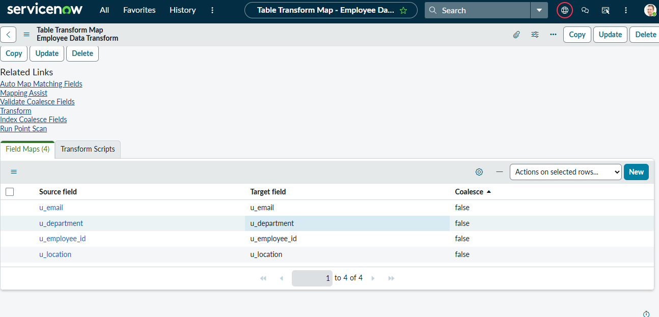

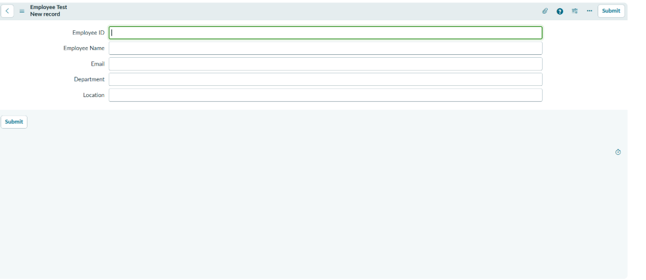
Milestone 2 : Creation Of importset Table And Transform Map
Create Importset Table

Description

Import Set Table
The Import Set Table is a temporary staging table used to store employee data uploaded from the spreadsheet. It contains fields such as Employee ID, Name, Email, Department, and Location. The imported data is stored in this table before it is validated and transformed into the final employee records.

Navigation:
Go to Application Navigator
Load Data
Click on Load Data and create an import table
Fill details as shown below
Label: Employee Import
Name: u_employee_import (auto populated)
Click on Submit
Once we click on Submit, we can see the success message as shown below.
Also we need to make sure to click on Create Transform Map

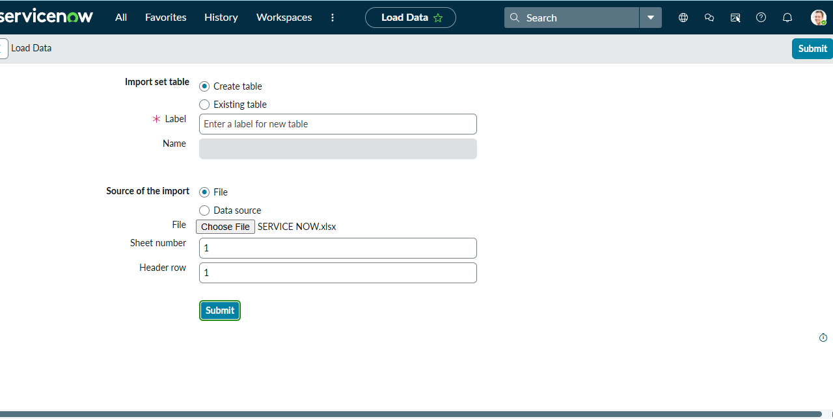

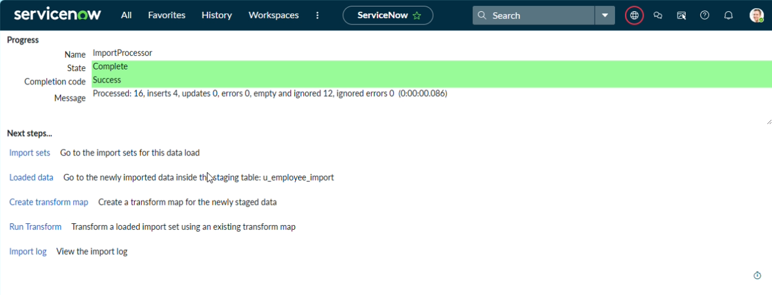
Create Transform Map
Description
Transform Map
The Transform Map defines how data from the Import Set Table should be transferred to the target Employee table. It maps fields such as Employee ID, Name, Email, Department, and Location from the imported data to the corresponding target fields. Employee ID can be used as the coalesce field to update an existing employee record or create a new record when the employee does not already exist.
- Give inputs as shown below.
- Name: Sample Spreadsheet Import
- Source Table: Employee Import is auto-populated
- Target Table: Employee Test - as we created earlier
- Click on Auto Map Matching fields.

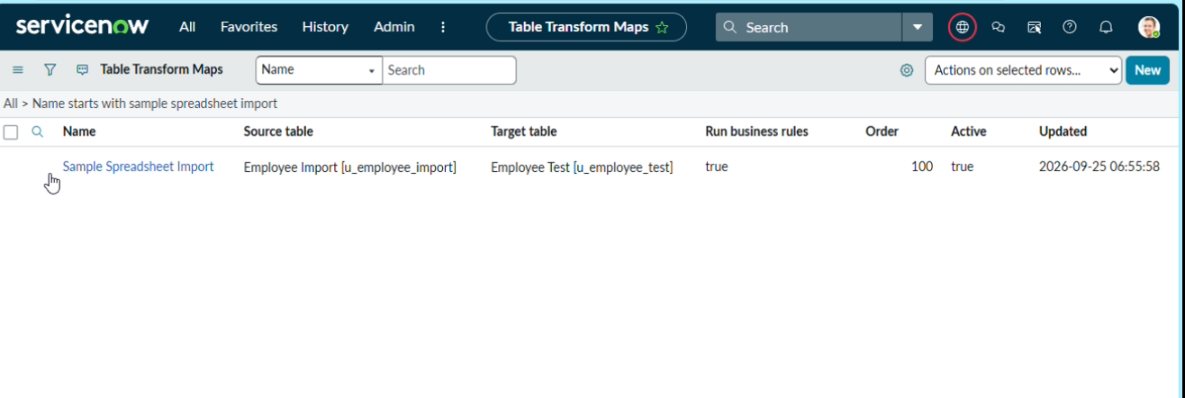

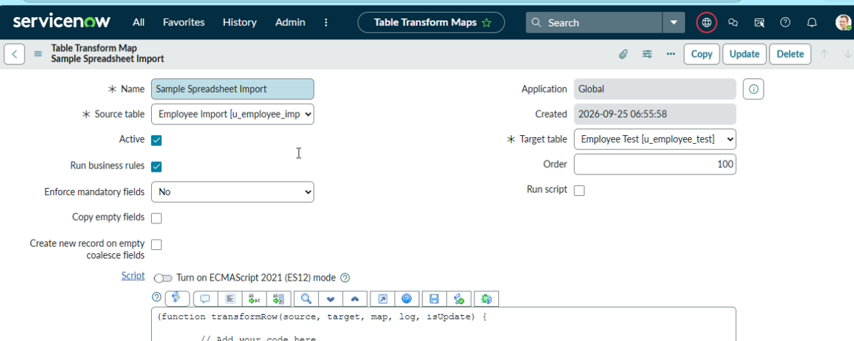

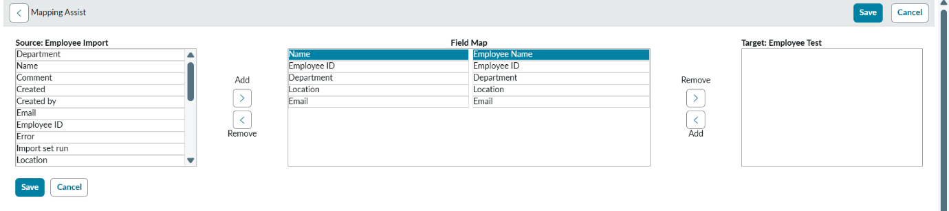

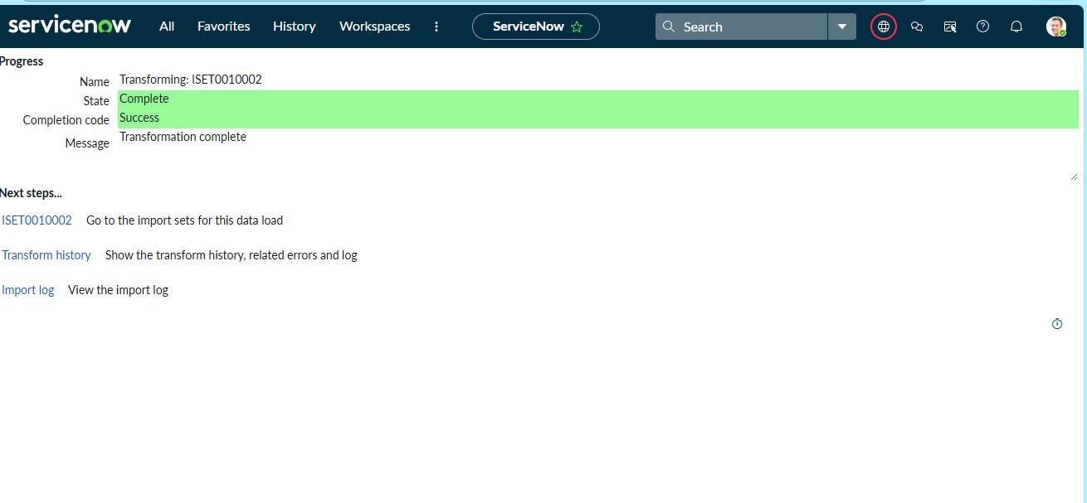
- Click on Save
- Make sure the both Source & Target table fields are mapped as shown below.
- Now click on Transform as shown below
- Now click on Transform link as shown below
- After clicking Transform, make sure you see the success message as shown below.

Milestone 3 : Transform Data & Validate And Enable Coalesce to Avoid Duplicate Records
Transform Data & Validate
Description
Transform Data
The Transform Data process transfers employee information from the Import Set Table to the target Employee table using the Transform Map. It maps and converts fields such as Employee ID, Name, Email, Department, and Location and ensures that the imported data is stored correctly in the target table.
Validate Data
The Validate Data process checks the imported employee information before it is added to the target table. It ensures that required fields such as Employee ID, Name, and Email contain valid data and helps identify incorrect or incomplete records so they can be corrected.
Navigation:
Open Employee Test Table from application navigator as shown below.
As our import got succeeded, all the records are created in the Employee Test Table.
Make sure you rearrange the fields accordingly by using Personalised List Columns
Click on OK
Final Result:
All the records are successfully imported into the ServiceNow system with Import Set, Transform Map.

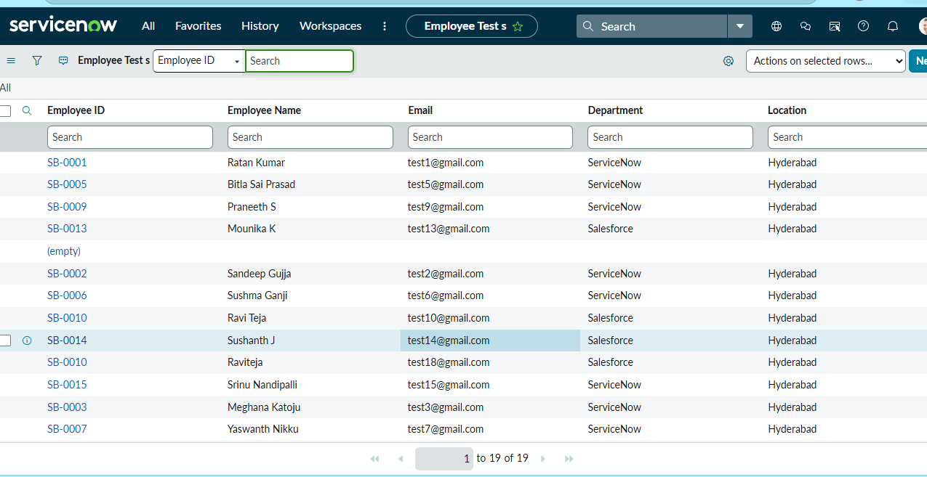
Enable Coalesce to Avoid Duplicate Records
Description
In real projects, the same employee data may be imported multiple times.To prevent duplicate employee records, we use Coalesce. The Coalesce will update the same records with new values if we add and the duplicate values are not inserted.
Steps:
Open Transform map Under System import sets On All menus.
Open the Created Transform map , Name is Sample Spreadsheet Import.
Under Related list, select the Field maps Section and Make any one field Coalesce True which appears in False.
Now save the form.
Then again add some data which is in Excel format.
Open Transform map Which You are Created
Go to field mapping
Go to coalesce field make true for one unique field

Inserting New Data In Excel Format
Description
Steps :
Navigate to All menus.
Search for Load data Under System Import set Open Load Data.
Fill the details as
Import set table as select Existing table {Employee Import}.
Source of Import is Select File and choose the file from Files.
Sheet number : 1, Header row : 1.
Now Click submit.
Newly Created Excel Data is this.
It is the previously added data.
Now, In this new data we added 4 rows of the 2 rows with the same existing data with different Name changed and Email changed.
That Raviteja Employee Email was Changed to
[test10@gmail.com → test18@gmail.com ].
And Employee ID with SB-OOO4 name was changed to
[Ajay kumar → Ajay].
And two other new Employee ID’s are added.
Now after submitting the form it appears as State Completed and Success.
Now Click the Run transform Under the next steps.
Then it opens Specify Import set and transform map which is previously selected transform map then Click Transform button.
Now the State is completed and Success.
Now again click on the Transform history then it shows the newly added data and its status of Inserted and Skipped values out the given data.
From the above figure : total 4 rows are uploaded out of 2 are Inserted that are two new ID’s.
And 2 rows are updates that are Same ID’s with different Name and different Email that we changed.
Then Open the Employee Tests table and see the rows updated and inserted.
Now Repeat the Phase 7 with the same steps and same Excel sheet and Submit to check how many rows are updated and Inserted with the same data.
Then Open the Transform history to check
Here we can see the total 4 are uploaded.
On that 0 rows are Inserted and updates 0 and Ignored 4 rows.
That same sheet we uploaded to the same transform map we created

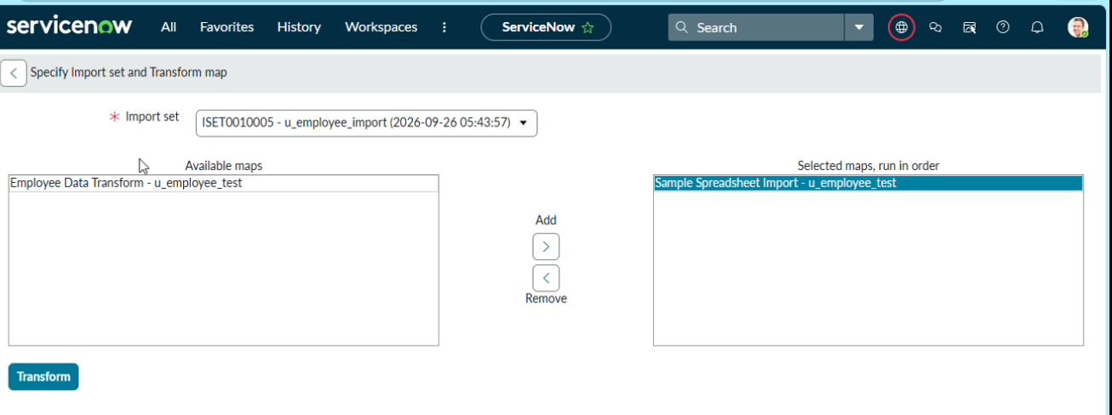
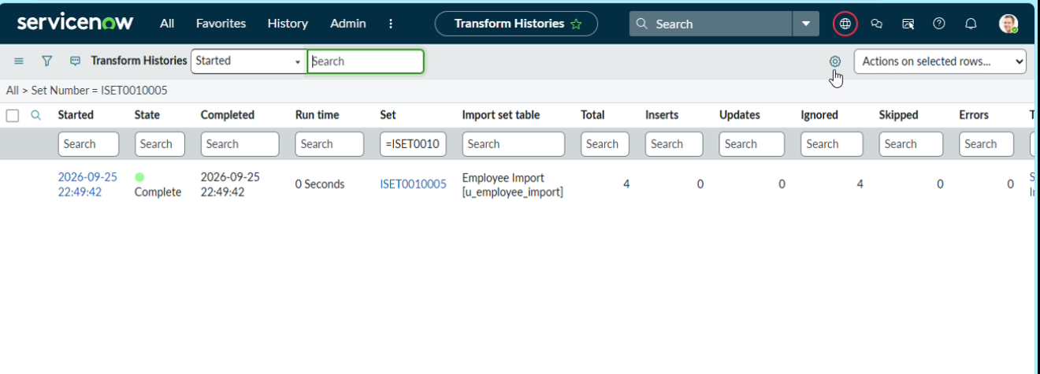
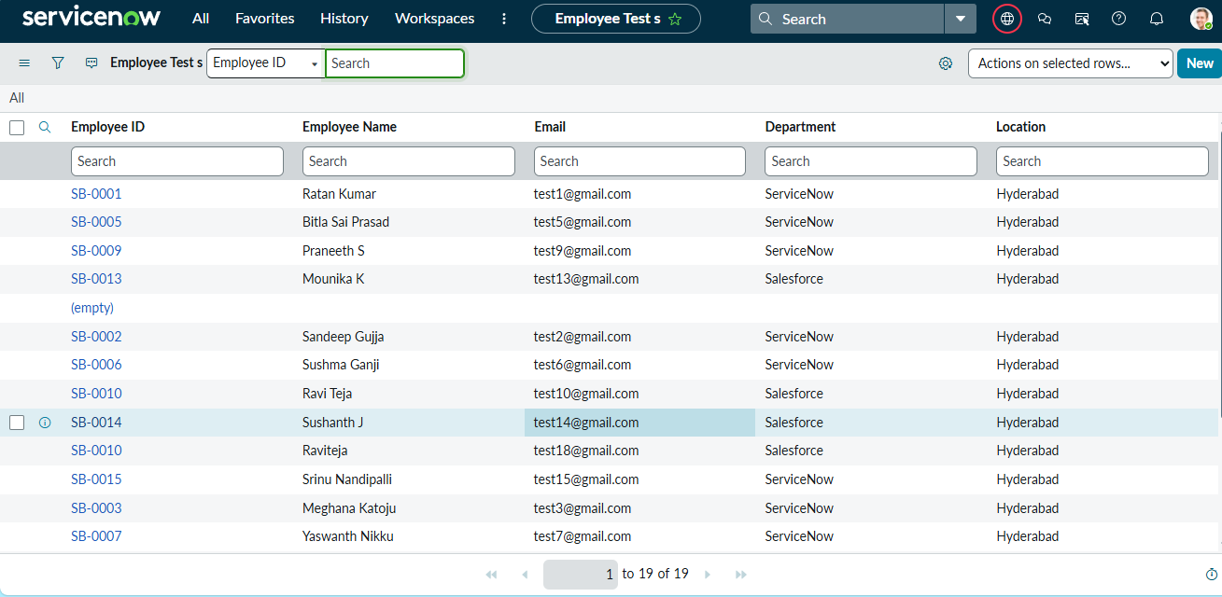
Milestone 4 : Creation Of reports & dashboards
Report 1
Description
Create Reports on Employee Test Table
Navigation Steps :
Open All menus, Search for Reports.
Under Usage and governance Select Reports.
Click the New button to create a new report.
Create 3 Reports as follows.
Report 1: Employees by Department
In Data
Report name : Employees by Department.
Source Type : Table.
Table : Employee Test, Now click the Next button.
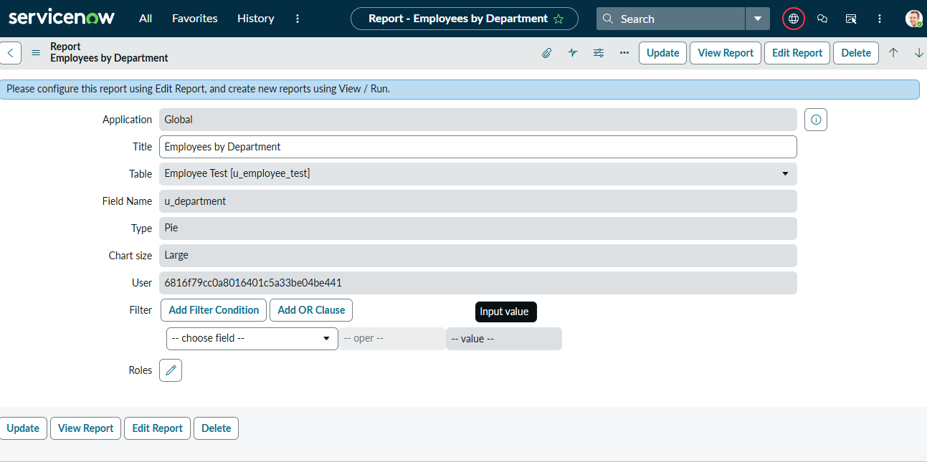
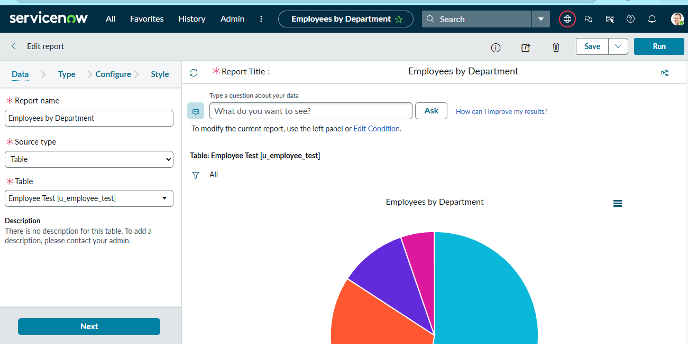
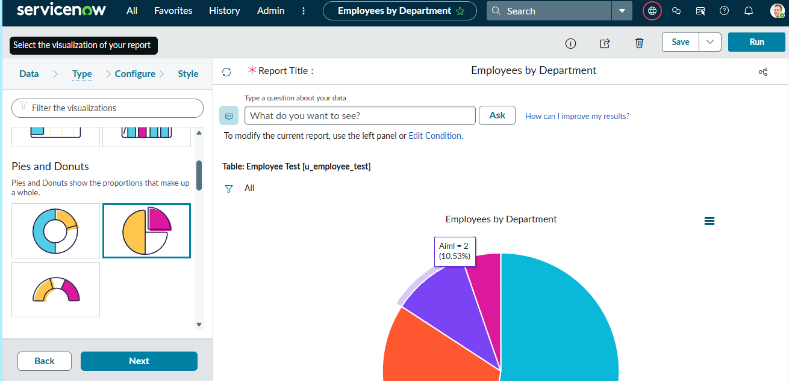
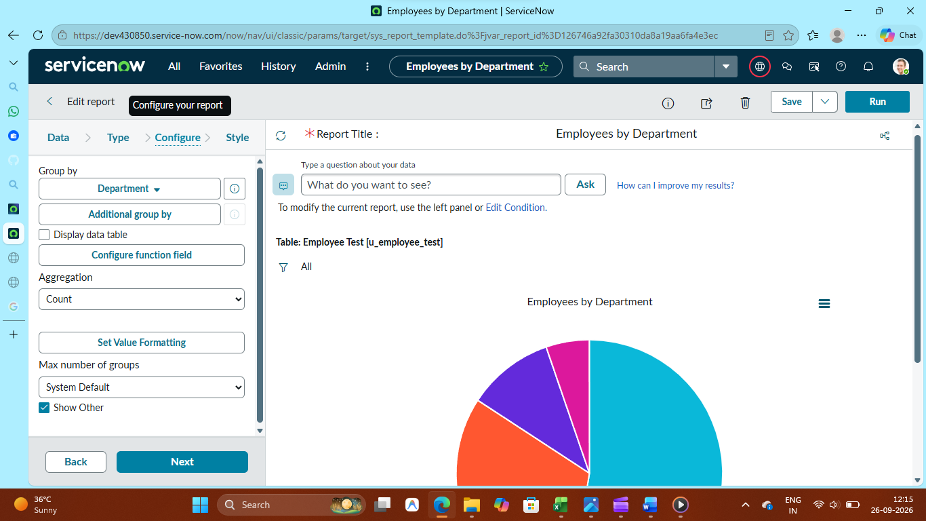
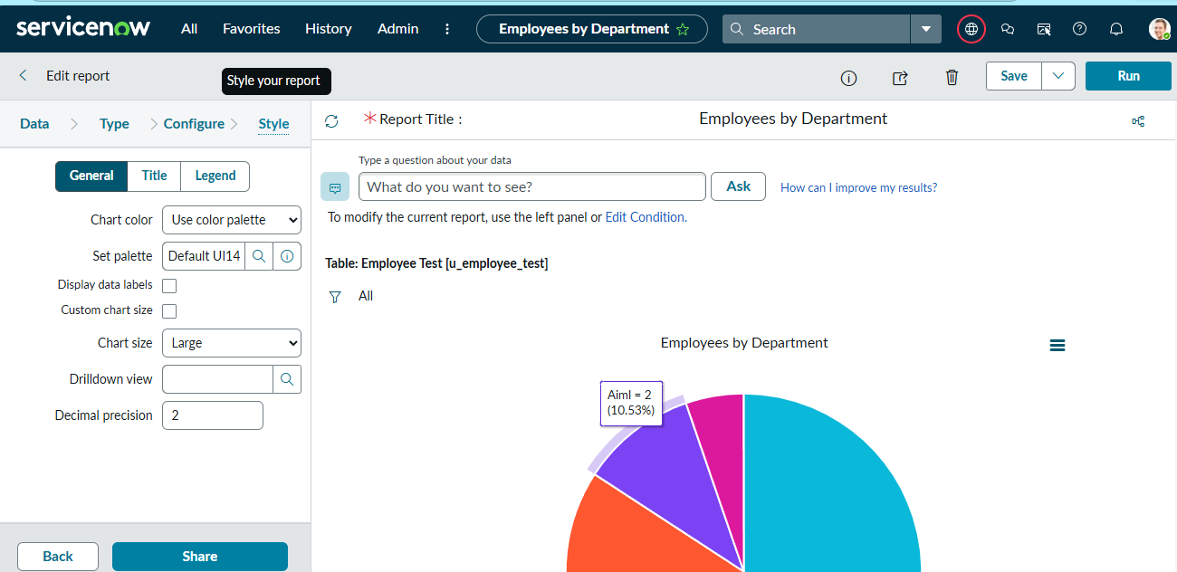

Now after Clicking next in type Select Pie chart .
And click the next button
Now In Configure Select Group by Department Field.
In the Aggregation Field Select Count.
Then Click next.
Now In Style Leave the Chart color by default.
And Click the Run button to Execute the given data Report.
And Click save button to Save the Report.
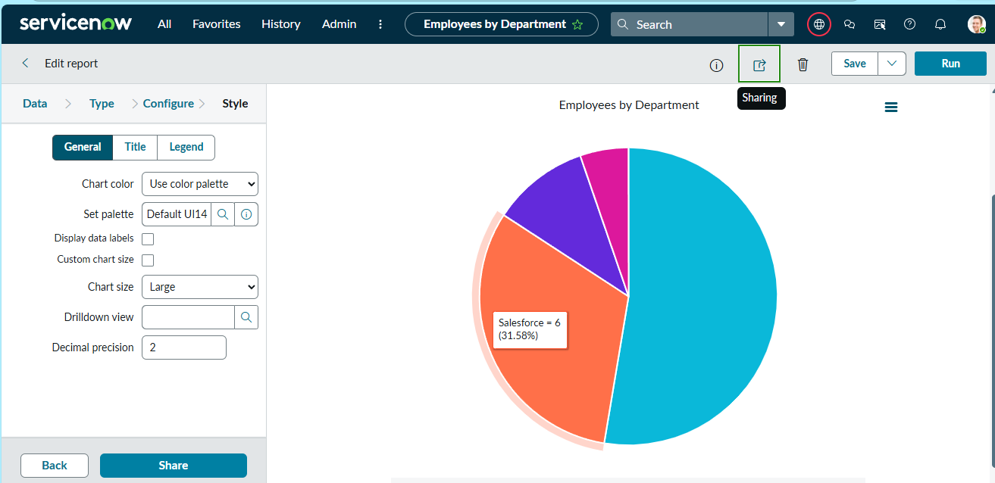
Adding Reports to Dashboard
Description
Create Dashboard
Navigation :
Open All menus → Search for Dashboards.
Under Self Service → Click Dashboards.
On the top right corner Click Create Dashboards or
You can create Directly by using the backend name[ PA_DASHBOARDS.FORM ].
Then Click New to Create new Dashboards.
Only the backend name will open the form if the ACL has the pa_dashboards access to Admin Overrides True only.
Then only we have access to the form
After Opening the ACL Search the pa_dashboards on Name Column
Now Open the Create Operation row
Then Click Enable the True for Admin Overrides and Update the Form.
Then the creation of dashboards will be possible by using the backend name.
Now Open the PA_DASHBOARDS.FORM create dashboard.
Dashboard name : Employee Analytics Dashboards.
Save the Form.
Add Reports to Dashboards.
Navigation Steps:
Open the Previously Created Reports.
On All menus → type Reports Under Usage and Governance select reports.
Open the Employees by Department.
Select the Edit Report and Click the Share button then the right top corner Select the Add to Dashboards Option.
Then Choose the Created dashboard name and Click Add button
Same Like that do the remaining 2 reports in the same navigation how we added Employees by Department.
The Employees by Location and Employee List Report these two reports are also added to the created dashboard.
After Opening the Report Click the View Report Button on the right side of the Context menu.
After Clicking the View Report button, Now Click the Share button and then share options are visible on the right side.
Now click the Add to Dashboards
Now Add the Dashboard that you created called Employee Analytics Dashboards.
Then Click Add button.
Now the Report is added to the dashboards.
Now, Same in the process, add the remaining two reports to the dashboard.
From the + icon also we add widgets that our reports from there.
If we want we can also configure the background color
Here the three Reports are added successfully by varying Department , Location and List Report.
We can also restrict the Users,Groups and Roles From Share Option.

Conclusion:
This project successfully implemented an automated employee data management solution using ServiceNow Import Sets and Transform Maps, ensuring accuracy, efficiency, and data integrity throughout the employee onboarding and update process.
A key enhancement in this project was the use of Coalesce in the Transform Map. By enabling Coalesce on the Employee ID field, the system intelligently identifies existing employee records during every import. This prevents the creation of duplicate records and ensures that repeated imports update existing data instead of inserting redundant entries. As a result, the employee database remains clean, reliable, and consistent, which is critical in real-world enterprise environments where data may be imported multiple times from external systems.
In addition to data integrity, the project was extended with Reports and Dashboards to provide meaningful insights and real-time visibility into employee data and import activities. Custom reports were created to track:
Total employee records.
Newly added employees.
Updated employee records.
Department-wise employee distribution.
Import success and error counts.
These reports were then consolidated into a Dashboard, allowing administrators and HR teams to monitor employee data trends, import performance, and data quality from a single centralized view. Dashboards improved decision-making by presenting information visually through charts and graphs, reducing the need for manual analysis

